

**Our company website starts with the <Navbar> (“we used the Bootstrap techniques for importing the <Navbar> The Logo which is mentioned here is replaced by Our company logo named “Amigo Groups” inside the images folder.**

**Our <Navbar> should consists up with <Home> <Products> <Teams> <Vision> “Build With US” as mentioned above in the picture should replaced with “Contact Us”**

**Here as you can see in the <body> section**

**There is a logo just by the sentence written “Amigo Groups” we removed this logo with a <div> to put a <video> there. As given here in this website**

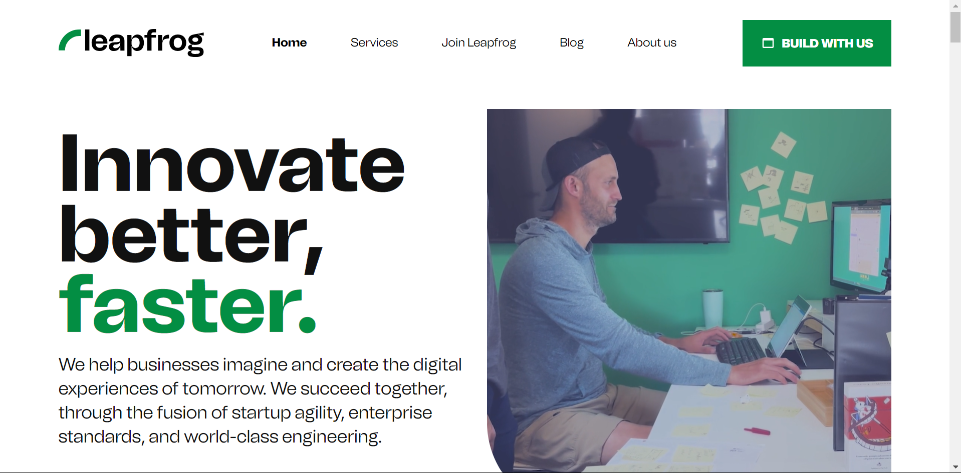

**You can clearly see in the pictures that a <div> has been used in the <body> section to use the <video> there.**

**Footer structure should be as followed**

**The logo of f1soft group as given here should be replaced with our company logo as given in the images folder inside our project we also replaced this “esewa” logo with our amigo trends logo “fone pay” logo with our amigo-story logo ..**

**Contact us here as given in the footer should be as followed:-**

**Amigo Groups Pvt Ltd.**

**Mail to** [**market@amigogroups.com**](mailto:market@amigogroups.com)

**Follow us**

**facebook. Icon attached with link->** [**https://www.facebook.com/profile.php?id=100094741429161**](https://www.facebook.com/profile.php?id=100094741429161)

**linked in Icon attached with link->** [**https://www.linkedin.com/company/amigo-groups/**](https://www.linkedin.com/company/amigo-groups/)

**YouTube Icon attached with link->** [**https://www.youtube.com/@amigostorynepal**](https://www.youtube.com/@amigostorynepal)

**The background colour of the footer should be #fbfdfe**

**The new <Navbar> Teams has been made the code for the same has already been written now have to follow the structure for the same..**

**The heading “About US” replaced with “About our Teams” The image here given in this segment should be replaced with our own images named amigo groups technology given in the images folder inside our company project.**

**The heading “Innovation is in our DNA” Here, in this heading <span> has been used in “Innovation” so we should have to used the same the colour for the same should be blue colour code is #233dff Our heading should be replaced with “Crafting Success Together: Unveiling Our Exceptional Minds” here <span> should be used in Crafting Success Together with a colour code of #233dff remaining should be used same .**